[The SMORPHI² TransfoBot](https://github.com/lightxLK/Smorphi-TransfoBot)

A transforming a robot was made in collaboration with **Wefaa Robotics** and **Singapore University of Technology and Design**, for showcasing the *blooming environments* in the field of *advance locomotion* and the *vast spectrum of Internet Of Things* [ IoT & Automation ].

Our Prestigious Mentors:

* Dr. Gyanaranjan Panigrahi
* Mr. Pritam Nanda
* Mr. Biswajeeban Mishra

The Mighty Team:

* Sahil Kumar Chaudhury
* Tejaswinee Nayak
* Tanushree Lenka



* Choudhary Abisant Jena
* Rudra Narayan Behera
* Lokesh Patra
* Pallav Palai



*“ Every step and procedure was performed in alignment with the guidance of all the mentors and the esteemed panel from Wefaa Robotics, Singapore ”*

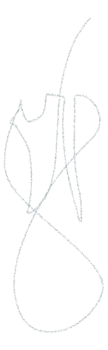

Step#1: Unpacking the smorphi² box, all the components were taken out of the box and spread on the floor, and the components were:

* 16 x Mecanum Wheels ( Right + Left )



* 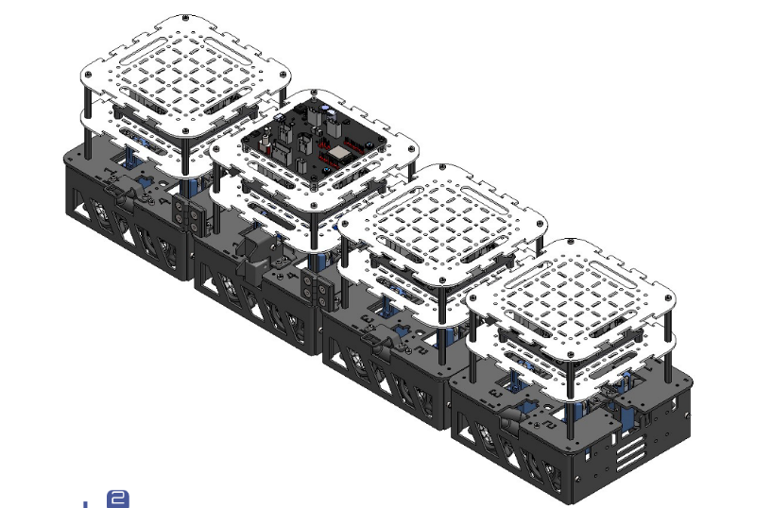4 x Aluminum Base Plates



* 8 x Acrylic Base Plates



* 16 x Mecanum Motors w/ Mounts



* 6 x Solenoids w/ Latch Mount, Guide & Catch
* 6 x Hinge Mounts
* 3 x Hinge Mechanisms



* 1 x LiON Battery
* 2 x Battery Bracket



* 1 x Masterboard [ Espressif32 ]



* 4 x [Slaveboard](https://github.com/WefaaRobotics/Smorphi/wiki/3.-Slaveboard)
* Multiple Sensors [ Sound, Temperature, InfraRed ] + HuskyCamera
* Multiple Size Screws [ 3 * 5 ( x200 ) + 3 * 10 ( x45 ) + 3 * 25 ( x50 ) + 4 * 8 ( x15 ), 45 * M3 Nuts ]



* 32 x Hex MF M3 Nylon 45mm
* 28 x Hex FF M3 Nylon 10mm
* 8 x 4-pin Connectors + 4 x 8-pin Connectors
* 1 x USB Type C + 1 x Battery Charger
* 2 x Wing Screws [ M3 * 5 ] + 1 x Ceramic Screwdriver + 1 Hex Key 1.5mm

Step#2: Through the video conferencing session, we were given a link:

[ ‘ <https://smorphi-documentation.readthedocs.io/en/latest/> ’ ]

* In that documentation website, there was a **Smorphi Assembly Manual**, of different versions, as w/o and w/ Voltage Regulator with multiple purchase periods as from:

*[ May ’23 – September ’23 – March ’24 – August ’24 – P R E S E N T* ]

* There, we chose the 3rd one, i.e. Smorphi² w/o Voltage Regulator [ May ’23 ~ August ‘24 ], and downloaded that manual.

Step#3: Motor Sub-Assembly [ A1 ; Pg. 7 ]

* Left & Right Mecanum Wheels are attached with their respective DC Motors, using Motor mounts, shaft sleeve and screws [ M3 * 22 ].

Step#4: Base Module Assembly [ A2 ; Pg. 8 ]

* On an Aluminum Base Plate, there are 4 grooves numbered [ 1, 2, 3, 4 ].
* Inside those grooves, the wheels are inserted according to odd-even layout as Right Wheels are Even Grooves [ 2 & 4 ], and Left Wheels are Odd Grooves [ 1 & 3 ].
* After fitting the wheels, Skirt Panels [ A & B ] are placed on the sides.
* Then, 4 x Hex M-F M3 Nylon 45mm Screws were tightened on the 4 corners of that Al Base Plate.

Step#5: Solenoid Latch Sub-Assembly [ A3 ; Pg. 11 ]

* On both sides of the Solenoid Latch, a latch mount and latch guide were attached with [ M3 * 5 ] screws, similarly 6 latches were joined.

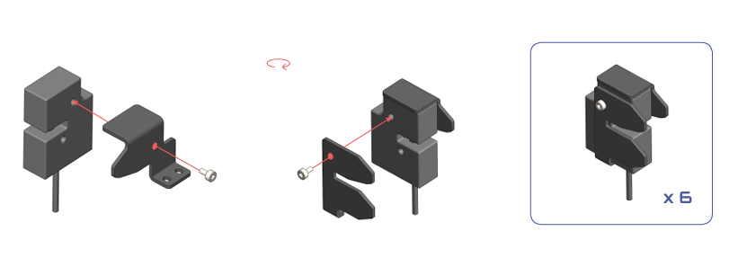

Step#6: Mechanical Sub-Assembly [ A4-7 ; Pg. 12-19 ]

* After assembling the parts respectively, now we got to assemble each module separately, according to the manual, in a very specific way of assembly of the 4 modules.
* Module 1:
  + 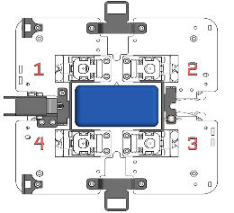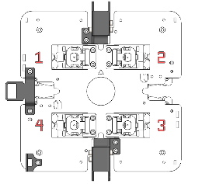2 Solenoid Latches are fitted, between 1 – 2, and 4 – 3.
  + 1 Solenoid Catch is fitted between 1 – 4
  + 1 Hinge Mount is fitted near 4th Corner of the Al Plate.
* Module 2:
  + 1 Latch is fitted between 1 — 4.
  + 2 Catches are fitted between 1 – 2, and 4 – 3.
  + 2 Mounts are fitted near 2 corners, 1 & 4.
  + Battery Brackets are installed, in the middled, tightened with a Wing Screw, along w/ the battery.
* Module 3:
  + 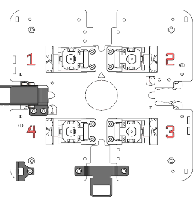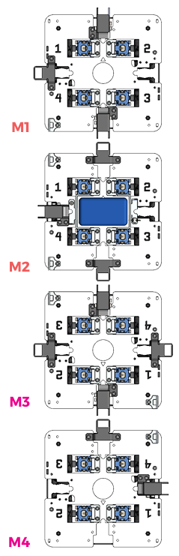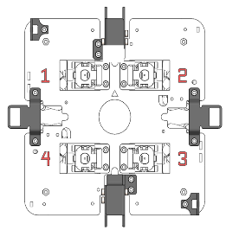2 Latches are fitted between 1 – 2, and 4 – 3.
  + 2 Catches are fitted between 1 – 4 and 2 – 3.
  + 2 Mounts are fitted near diagonal /odd corners, 1 & 3.
* Module 4:
  + 1 Latch is fitted between 1 – 4.
  + 1 Catch is fitted between 4 – 3.
  + 1 Mount is fitted near the 4th Corner.

Step#7: Full Mechanical Assembly [ A8 ; Pg. 20 ]

* All 4 modules are aligned together as [ 1 -M1- 4 ] > [ 1 -M2- 4 ] > [ 3 -M3- 2 ] > [ 3 -M4- 2 ], i.e. M3 & M4 are rotated 180° from M1 & M2.
* After this alignment, the 4 modules are locked to each other, and the 3 hinges were attached to the hinge mounts.

Step#8: E-Tray Sub-Assembly [ B1 ; Pg. 24 ]

* Hex F-F M3 10mm holes were attached to the acrylic base plates with [ M3 x 5 ] screws.
* Then, the slaveboards were attached onto those holes using more screws.

Step#9: E-Tray onto Mechanical Assembly [ B2 ; Pg. 25 ]

* The Motor Connectors on the Slaveboards are oriented with the Al base plate numbers, i.e. Motor 1 > 1, Motor 2 > 2, etc.

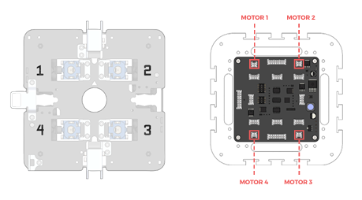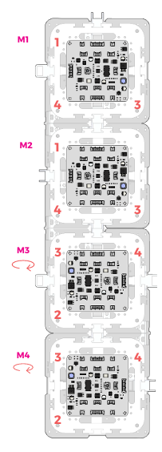

Step#10: Motor Cable Connections [ B3 ; Pg. 29 ]

* All DC Motors of the tires are connected to their respective Motor Connectors [ *M1 > MC1, etc.* ]

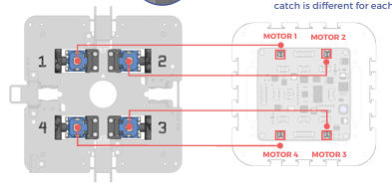

Step#11: Solenoid Cable Connection [ B4-7 ; Pg. 30 ]

* Module 1:
  + Latch [ 1 – 2 ] connected to Solenoid 1 Connector.
  + Latch [ 4 – 3 ] connected to Solenoid 2 Connector.
* Module 2:
  + Latch [ 1 – 4 ] connected to Solenoid 1 Connector.
* Module 3:
  + Latch [ 1 – 2 ] connected to Solenoid 2 Connector.
  + Latch [ 4 – 3 ] connected to Solenoid 1 Connector.
* Module 4:
  + Latch [ 1 – 4 ] connected to Solenoid 1 Connector.

Step#12: InterModule Cable Connection [ B8 ; Pg. 34 ]

* 3 * 8-Pin Wires are connected from Head to Tail Connectors of all the boards, as
  + M1 – M2, & M2 – M3 are wired via 1 – 4 sides.
  + M3 – M4 is wired via inverse 1 – 4 side [ *180°* ]

Step#13: Address Selection [ B9 ; Pg. 35 ]

* The Ceramic Screwdriver was used to adjust the rotary switch for respective address of each module as:
  + Module 1: Address 0
  + Module 2: Address 1
  + Module 3: Address 2
  + Module 4: Address 3

Step#14: Masterboard E-Tray Sub-Assembly [ B10 ; Pg. 36 ]

* Exactly as the Slaveboard attachment, the Masterboard is attached to an acrylic base plate, on **Module 2**.

Step#15: Masterboard E-Tray onto Main Assembly [ B11 ; Pg. 37 ]

* The header to slaveboard connector on the Masterboard is aligned to face the 1 – 4 side of the slaveboard.
* Post-alignment, the an 8-Pin wire is connected from [ Header to Masterboard ] to [ Header to Slaveboard ] connectors in both the boards, respectively.

Step#16: Acrylic Covers [ B12 ; Pg. 39 ]

* Rest of the modules [ M1, M3, & M4 ] are attached with Acrylic Covers, using M3 x 5 screws.

Step#17: Battery Connection [ B13 ; Pg. 40 ]

* Ensuring the battery is fully charged, it was already placed in the Battery Bracket, and now its wire is connected to the Battery Connector on the Mainboard.
* Finally, the toggle switch is turned on, and if all the LEDs in all modules **lit** up, it was assured that all connections were properly made!
* After that, the ENABLE button is held for 1second to activate the robot.

*_ smorphi² Assembly Complete _*

Step#18: Application Connection

* [Smorphi](https://play.google.com/store/apps/details?id=de.kai_morich.smorphi_app) application was installed on our smartphones, from PlayStore.
* After installing, we scanned the room through the app, using BLE ( [Bluetooth Low Energy](https://github.com/WefaaRobotics/Smorphi/blob/V2.0_HT/Smorphi2/demo/Smorphi_Square_BLE_Demo/Smorphi_Square_BLE_Demo.ino) ) technology.
* Once, Smorphi is detected in the list, we connect to it and launch the controller.
* Then, we were introduced with various buttons as a JoyStick, several shape transforming controls [ O, I, L, T, J, S, Z ], and 2 Pivot Turning buttons, which when held, pivoted the robot in clockwise and anti-clockwise directions.

Step#19: Sensor Configuration [ Sound Sensor ]

* A sound sensor was connected w/ a 4-pin cable to the Module 1, GPIO0 port.
* Then, it was coded through Arduino IDE.
* For the programming purpose, the USB A to C cable was connected from the [Masterboard](https://github.com/WefaaRobotics/Smorphi/wiki/2.-Masterboard) to our laptop.
* The laptop was previously [set-up with the necessary drivers](https://github.com/Biswajeeban/B.Tech.-IoT-V-July-2024/blob/Lokesh/Lokesh/Lab.%20Records/Lab%237_ESP32%20%F0%9F%90%BF%EF%B8%8F.md) [ **CP210x USB to UART Driver** ], and necessary libraries in the IDE.
* After the connection, [a sound sensor code](https://github.com/WefaaRobotics/Smorphi/blob/main/exercise/exercise_10/exercise_10.ino) was uploaded onto the laptop and then our robot was ready to perform the Sound Sensory Acts.

_ *Disassembly* _